**Feedback on Screenshots**

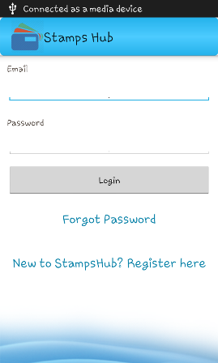

Good - no comments on functionality

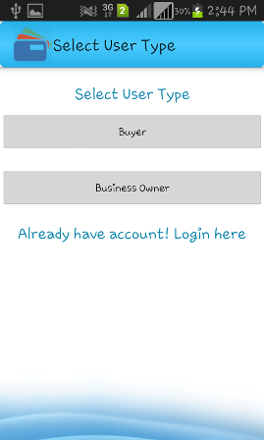

-Change ! to ?  
- Change "Buyer" to "Customer"  
- Change "Business Owner" to "Business" only  
- Change "Select User Type" to "I am a..."  
- Put a space between "Log" and "in".

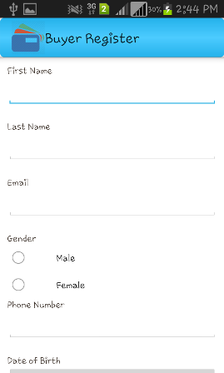

- Change title to "Sign up as a Loyalty Stamps Collector"  
- Try to put input field on the same line as the label  
- Order as follows: firstname, lastname, gender, dob, email, mobile number  
- Change any screens with wording "register" to "sign up"

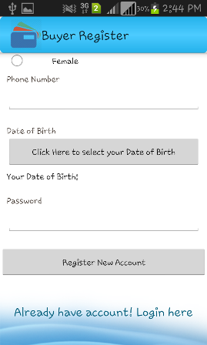

- Please email me a screenshots of the Date of Birth selection. If this opens a calendar, then I rather have 3 drop-downs: 1 - 31, January - December, 1920 - (this year - 12). I.e. user's minimum age is 12 years. I am open to changing the minimum age if you suggest otherwise. I just thought that at this age, a child in today's digital age might be interested in using the app. I am not expecting a huge customer base at this age, but we should cater for this age.  
- Change "Register new account" to "Sign up"  
- Remove link with existing account

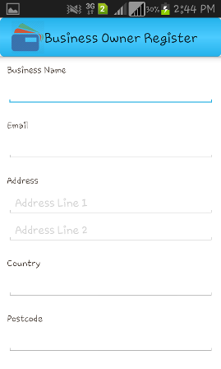

- Change to title to "Sign up a business"  
- Put email after address  
- Add to address "county" and "postcode" like for address line 1 and 2 i.e. remove the separate labels for country and postcode. For now we are targeting only the UK, therefore we know it is UK businesses only. In the future, either this app will be changed to include Country or we will create separate apps for individual countries since non-English speaking countries will be able to select a language either native or English. We need to think about this in the future.

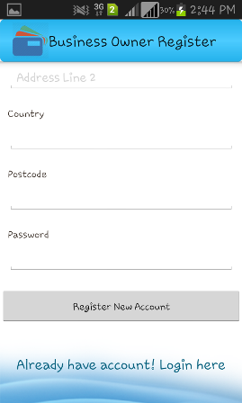

- Remove link with already existing account

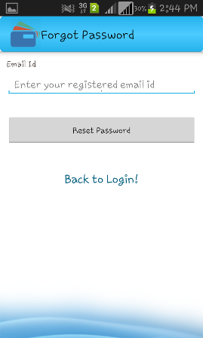

- Remove "back to login"

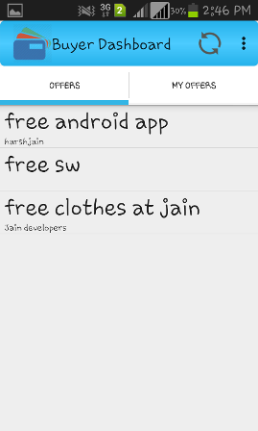

- Leave this for now as it is. This offers feature is a bit more complicated and I will document the requirements in due course. Although what you have developed is good and will be useful and usable to meet the requirements but with a wider and more interesting funtionality.

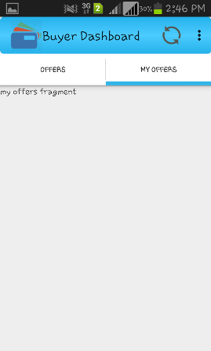

- Same applies as I noted in my above comment

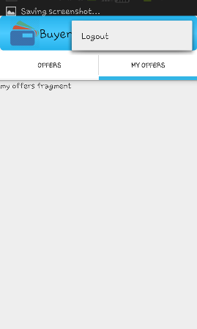

- Good - no comments

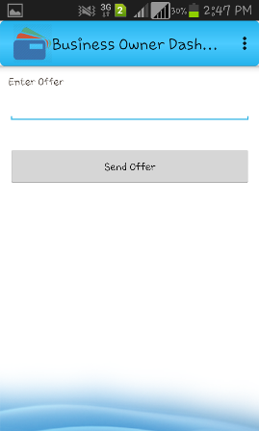

- No comments, but will elaborate on this feature as mentioned above.

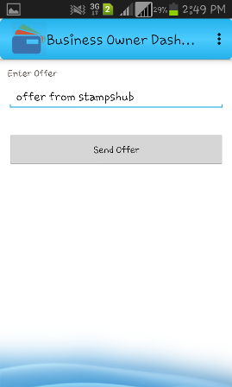

- No comments, but will elaborate on this feature as mentioned above. There will be additional data fields that have to be captured which I will also explain the specification. There is no "sending of offers" but it will be a "publication of offer" which then gets pushed through relevant customers.